Name: Date:

Magnetic Poetry

Directions: The original magnetic poetry kit contains many carefully chosen words and word fragments so you can literally create billions of poetic masterpieces. Using the kit, create your own work of art.

Magnetic Poetry Sample

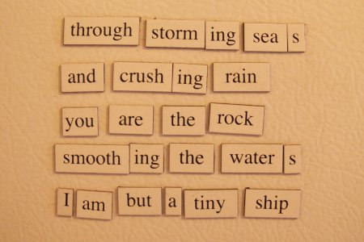

Your Original Poem

